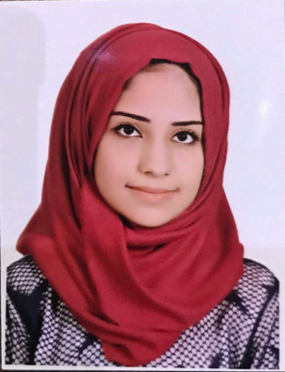 Safa Abdulhadi Abbas

Date of Birth : 20/11/1996

Address : Baghdad – Alkarada

Gender : Female

Phone : 07718504772

**Objectives:**

Looking for position as an employee in a Company as I have the experience I gained from the college in Accounting Field

**Certifications and Qualifications:**

- Bachelor Degree in Accounting / Al-Israa University College ( 2017 – 2018 )

**Experience**

- I had a Training Course in the second and third stage of the college at Earth link Telecommunications in Karada / Arasat on the different Accounting Programs and a briefing on all the departments.

**Abilities And skills :**

* Good skills in English language. ( Understanding , reading , writing )
* Motivated employee accomplishing work with multi task skill.
* Working in team environment and under hard pressure.
* Can work on Computer for different Accountant Programs.
* Well knowing in communicating with Customers.
* Can Use MS office ( Word – Excel ).